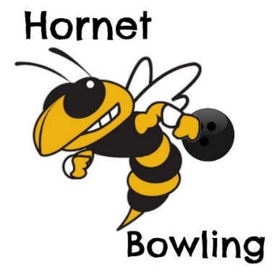 **2019 Bowling Schedule**

* **Sept 4th Yulee vs Sandalwood/Fletcher at Bowl America South**
* **Sept 23rd Yulee vs Baldwin/Jackson at Batt Bowling**
* **Oct 1st Yulee vs Fernandina at Nassau Bowling**
* **Oct 3rd Yulee vs West Nassau at Nassau Bowling**
* **Oct 7th Yulee vs Englewood/Jackson at Batt Bowling**
* **Oct 10th Yulee vs Hilliard at Nassau Bowling**
* **Oct 22nd County Championship**
* **TBA District Tournament**

**Head Coach: Fred Matricardi**

**Yulee High School 225-8641**